Las Vegas Algorithm – Randomized QuickSort
A Las Vegas algorithm is a randomized algorithm that always gives correct results, that is, it always produces the correct result or it informs about the failiure. In other words, a Las vegas algorithm does not gamble with the correctness of the result, it gambles only with the resources used for the computation. A simple example is Randomized QuickSort.
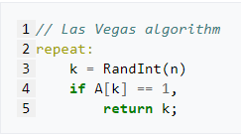
As mentioned in Figure-1, Las Vegas algorithms always return correct results. A variable k is generated randomly; after k generated, k is used to index the array A. If this index contains the value 1, then k is returned; otherwise, the algorithm repeats this process until it finds 1.
Figure – 1
Although this Las Vegas algorithm is guaranteed to find the correct answer, it does not have a fixed runtime; due to the randomization (k = RandInt(n)), it is possible for arbitrarily much time to elapse before the algorithm terminates.
Randomized QuickSort
A common Las Vegas randomized algorithm is quicksort, a sorting algorithm that sorts elements in place, using no extra memory.
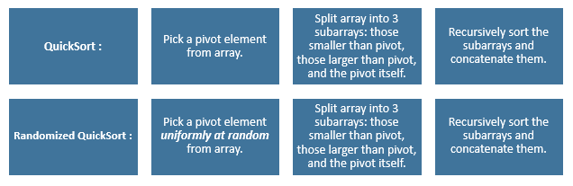
Quicksort applies a divide-and-conquer paradigm in order to sort an array of numbers, A. It works in three steps: it first picks a pivot element, A[q], using random number generator (hence a randomized algorithm); then rearranges the array into two subarrays A[p. . . q - 1] and A[q + 1 . . . r], where the elements in the first and second array are smaller and greater than A[q], respectively.
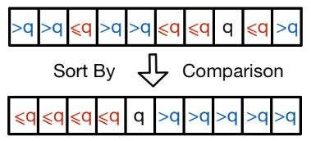

Figure-2 : Array A sorted and partitioned around pivot element q.
Pseudocode of Randomized QuickSort Algorithm

INPUT :
# A is an array of n elements
def randomized_quicksort(A) :
if n = 1 :
return A # A is sorted.
else :
i = random.midrange (1 , n) # will take a rand number in the range 1~n
X = A[i] # the pivot element
“”” Partition A into elements < x, x, and > x
Execute Quicksort on A[1 to i-1] and A[i+1 to n].
Combine the responses in order to obtain a sorted array. “””

Time Complexity of Randomized QuickSort Algorithm
It is obvious that Randomized QuickSort always generates the solution which in this case the sorted array. Unfortunately, the time complexity is not that obvious. It turns out that the running time depends on which element we pick as a pivot.
The worst-case O($n^{2}$), when the pivot is the smallest or the largest element.
T(n) = T(0) + T(n-1) + Θ(n)
T(n) = Θ(1) + T(n-1) + Θ(n)
T(n) = T(n-1) + Θ(n)
T(n) = Θ($n^{2}$)
However, through randomization, where the pivot is randomly picked and is exactly a middle value each time, the QuickSort can be done in O(n log(n)).
$T\left(n\right)≤2*T\left(\frac{n}{2}\right)+Θ\left(n\right)$
T(n) = Θ(n log(n))

